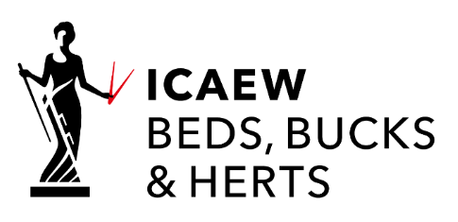

IT’S YOUR SOCIETY
Nominations for service on management committee to May 2026
Beds, Bucks & Herts District Society is the ICAEW’s local member community and is here to represent all its members in the area, at whatever stage in their career, including those who are recently qualified or working in business, public and third sectors.

Serving on the committee gives you the opportunity to participate in the management of your District Society, which is an important bridge between the local communities across Beds, Bucks & Herts and ICAEW centrally. By doing so you can help it to identify and support key activities for members and influence how policies can be improved nationally. At the same time, you will expand your network of professional contacts. To hear more from ICAEW Chartered Accountants who volunteer please visit icaew.com/bbh

If you have an enthusiasm for new ideas and want to champion these to fellow members, then get involved by completing and returning the form overleaf. If you’d like to find out more, please contact kim.shield@icaew.com or call +44 (0)1223 654 682.

- Under the Society’s rules, nomination of candidates for election or re-election to the Management Committee at an Annual General Meeting must be made by notice in writing*:
- signed by not less than THREE members of the District Society;
- received by the secretary no later than 1 April preceding the date of the meeting, ie by 1 April 2023; and
- accompanied by confirmation in writing from each candidate of their willingness to serve if elected or re-elected.

- Nominations can be made by letter to the address below or by email to the society at kim.shield@icaew.com

- If more nominations are received than there are vacancies on the Management Committee, the vacancies will be filled by a ballot of those members eligible to vote who are present at the Annual General Meeting in person [unless a poll is demanded by not less than five members eligible to vote and present in person or by proxy]. The names of members elected or re-elected to serve a three year term until May 2026 will be announced at the AGM.

- Any member wishing to bring before the Annual General Meeting any motion not relating to the ordinary business of the Society may do so provided:-
- that notice in writing of the proposed motion be sent or given to the Secretary (via email at kim.shield@icaew.com) and be received no later than 1 April 2023; and
- that not less than five members entitled to vote at the Annual General Meeting shall have sent or given notice in writing to the Secretary (as above) not later than 6 April 2023 expressing their intention that the proposed motion should be brought before the Annual General Meeting; and
- that in the opinion of the President of the Society the proposed motion relates to matters affecting the Society or the accountancy profession.

- The AGM will be held on Monday 22 May 2023 starting at 19:00. A formal notice will be issued to members of Beds, Bucks & Herts District Society in accordance with its rules.
*form on reverse of this Notice

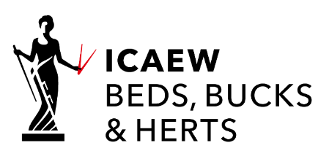

ELECTION TO MANAGEMENT COMMITTEE 2023
The following member of the Management Committee retires by rotation at the 2023 Annual General Meeting in accordance with Rule 9(a):

Paul Hingston*

The following co-opted members of the Management Committee retire at the 2023 Annual General Meeting in accordance with Rule 6(b):

Crystal Boston* | Finlay Everington*

Consequently there are vacancies available in addition to those who are retiring and standing for re-election at the Annual General Meeting on Monday 22 May 2023. Nominations for election, supported by a minimum of three members of ICAEW Beds, Bucks & Herts, are requested and must be received by Kim Shield (via email at kim.shield@icaew.com or at the address given below) not later than 1 April 2023.

*have confirmed their intention to stand for re-election

ICAEW BEDS, BUCKS & HERTS SOCIETY OF CHARTERED ACCOUNTANTS

MANAGEMENT COMMITTEE ELECTION

NOMINATION FORM
(To be received not later than 1 April 2023 via email at kim.shield@icaew.com or at the address given below)

WE HEREBY NOMINATE

I AM PREPARED TO STAND FOR ELECTION AND TO SERVE IF ELECTED

SIGNATURE OF NOMINEE DATE

NOMINATORS (A MINIMUM OF THREE ICAEW BEDS, BUCKS & HERTS MEMBERS)

Membership no. |  | name |  | signature

