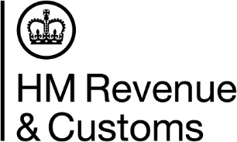 |  |  | Indv and Small Business Compliance
Complex and Agents
ISBC Direct Tax Repayment Credibility
HM Revenue and Customs
BX9 1QE
Mr A Taxpayer
123 Tax Lane
Tax Town

 |  |  | Phone | 0300 200 3310
 |  |  | Web | www.gov.uk
Date 6 January 2021
Our Ref ISBC/LIVAAS/SURF1/ /AO

Verification needed for a Self Assessment repayment claim

Unique Taxpayer Reference (UTR): | XXX
Your reference: | SURF1

Dear XXX
We are writing to you about an Income Tax Self Assessment (SA) repayment claim.
The claim was made using the UTR shown above.
We have reason to believe that this UTR may have been used to submit a potentially fraudulent repayment claim.
We are responsible for the administration of the UK’s Tax, Payments and Customs Authority. We take this very seriously and are continuously monitoring systems and customer records to check for fraudulent activity.
What you need to do now
If you have submitted this repayment claim, phone us on 0300 200 3310 by [30 days ahead]. This is so we can confirm certain details with you.
Following on from this, you will also be asked to provide us with documentary evidence of your identity.
We can deal with you more quickly if you quote your Unique Taxpayer Reference Number (UTR) and provide a daytime telephone number.
If we do not hear from you, we will cancel the repayment claim and close down the SA record and UTR.
Failure to respond to this letter will result in additional checks being applied to any claim made under the Self-Employment Income Support Scheme. This could delay or stop you from receiving a payment.

Yours sincerely

ISBC/AAS Compliance Team

