BPM Community
Reporting KPIs – design guidelines

Author |  |  | Date
Company |  |  | SBU
Issued to |  |  | Version

Purpose of guidelines
- Despite the introduction of technology solutions, there is generally still a requirement to produce a hard copy summary of KPIs for presentation to boards and executive committees, often in the form of a balanced scorecard.
- There is an almost infinite way of summarising KPIs into a one page summary: however, the correct design choices will have a significant impact on the effectiveness of the report as a decision making tool.
- This guideline provides a structured way of making these design choices and should increase the effectiveness of the end product.
- Treat the guideline as design guidance – there is no universally accepted format for reporting and the key is to present with confidence and insight – see the communications section of the BPM concept map for more detail on this.

----§----

Overview of guideline
- This guideline is based on extensive years of practical and specialist experience, with this topic. By using this guideline you will accelerate and improve a difficult process
- Most performance measurement systems fail to satisfy their users and fail to be the key tool they should be in managing the organisation – by following this process you will dramatically improve your prospects of success
- Additionally, by following this process you may arrive at a more cost effective solution – consultants will put a value on their intellectual capital that you are in effect getting for free by using this guideline
- This is not to deny that consultants can add value – but use them selectively and use subject matter experts rather than those with more generic skills

- Using this guideline
  - This guideline requires you to answer two types of question:

- Questions that determine choice of design - referred to as design questions

- Questions that populate the chosen design - referred to as detailed questions

  - Answers to the first questions will direct you to the appropriate template design. Answers to the second set of questions will help you design the content and lay out of the chosen design framework.

----§----

- Design questions
Use strategy map template tab

Proceed to detailed questions
2.1 Is there a requirement to use a strategy map on the one page summary?
Yes

NO

Use four quadrant template tab

Proceed to detailed questions
Yes
2.2 Do you want to use a four quadrant approach to reporting?

NO
2.3 Use tabular template tab

Proceed to detailed questions

- The strategy map version is useful where there is a strong desire to reinforce strategic guidance throughout the organisation and where there is a clearly articulated and accepted strategy
- The four quadrant version is particularly good for traditional scorecard applications: sometimes a further section is added in the centre of the page to highlight a limited number of usually financial metrics which are the key targets set for the organisation by its parent
- The tabular format version is useful where monitoring of both individual period and year to date results is important since it allows more columns: in this case you can show descriptions in middle of page to split out month and year to date columns

- Detailed questions: categorising your KPIs
Allocate your KPIs by your headings
3.1 Have you determined how you are going to sort/categorise your KPIs?

Yes

NO
Consider options such as:
- By scorecard quadrant (customer, operational effectiveness, organisational development, financial results) [See Note 1]
- By critical success factors
- By strategic imperative or other existing strategy breakdown
- Consider your own way of sorting KPIs

Note 1: The balanced scorecard quadrants are a typical way of sorting KPIs but in cases where much effort has been spent on defining strategy and communicating it, aligning KPIs to the existing summary list reinforces strategy and gets quicker acceptance.

Generally the summary page should contain no more than 20 KPIs - more than these risks diluting key messages. However, initial implementations often have more since there is a reluctance to cull KPI lists that have been put together collaboratively. The danger then is that a two tier set of KPIs emerges but without any rigour.
Warning!

Once you have made your choice made, update your pro-forma with summary headings and list KPIs under each heading
Action

----§----

Detailed questions continued: Reporting Periods
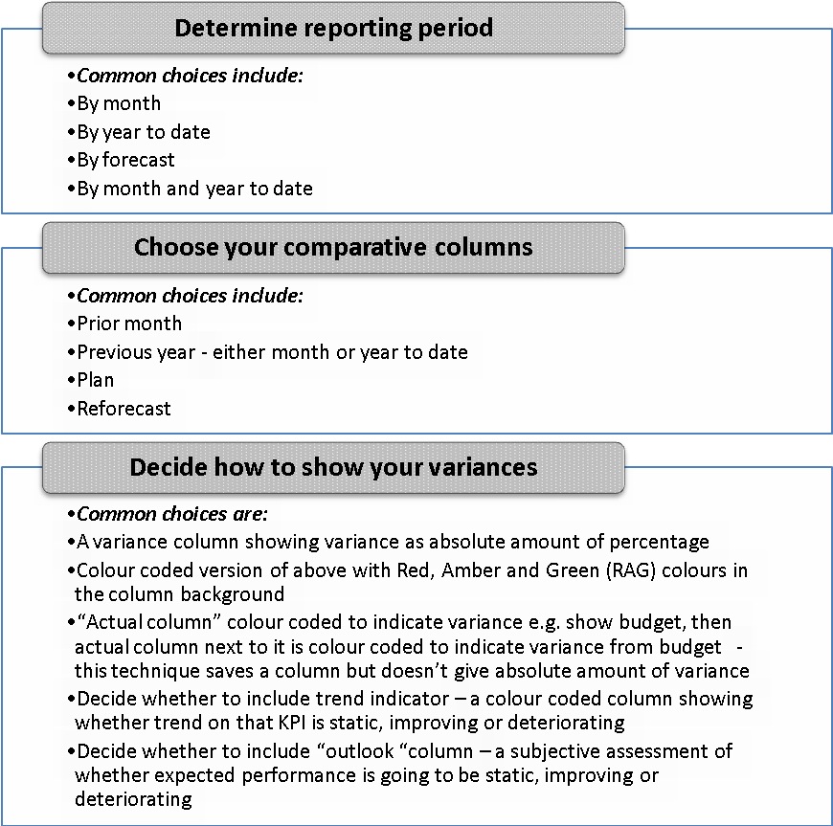
Add additional columns to template
Action
Action
Update column headings on template
Insert headings onto template
Action
- Add chosen additional columns (six to eight should be sufficient) to the template, paying close attention to the sequence in which they are displayed. Revisit if necessary to avoid an excessive number of columns.
- Ensure key messages are being conveyed.
- The key driver of your reporting period selection is whether the meeting at which the summary is presented is more concerned with current period performance, cumulative performance or the likelihood of hitting target. Whilst all three are important, generally one is the main focus and the others can then be picked up in support pages.

----§----

- Review final design
By following the above steps, you will have a one page business performance summary.
Once the design is finalised, consider the following questions:
- Is there an opportunity to align it with the house style – fonts, colours, logo etc?
- Is it legible? – do not go for too small a font to fit more in – in management information the old adage that “more is less” still holds sway
- Have you considered data ownership, data definitions, data commentators and the other implementation considerations discussed elsewhere on the BPM site?
- When seeking sign off for the design template from key users, have you been able to populate the summary with live or historic data? A design with only dummy data does not get the same response from users.
- Is the design consistent with any online business intelligence tools you will be using?

----§----

- Agree supplementary pages
The Business Performance Management Report can have various labels such as balanced scorecard, strategic performance report, monthly executive pack etc. but the one page summary is normally only one of a number of pages.
Typical supplementary pages include:
- Detail pages providing more analysis on either individual KPIs or groups of KPIs
- Commentary on market context – competitor actions, regulatory developments, economic indicators and so on
- Investor relations analysis – share price movements, volumes of share activity, contact activity
- Issues analysis – more detail on red KPIs describing issue, significance and management response
- Update on previous issues and actions
- Update on project delivery or strategic programme delivery
- Data definitions and owners appendix with key contacts
- Analysis of forecast – techniques such as “windsocks” charts to look at reasonableness of forecast
- Reconciliation of reported results to statutory or regulatory results

----§----

- Use of templates
The attached templates provide guidance but as part of your overall BPM strategy, you will have determined your delivery method and software support – we have included excel formats to illustrate the design but that does not imply endorsement of excel over other tools.
Most business intelligence software suites will have embedded reporting tools, often with Excel add-ins so these should be used where available since they will offer greater control, integration and flexibility.

----END----
© ICAEW 2013

