

THE BUSINESS
FINANCE GUIDE
A journey from start-up to growth
New edition
THE BUSINESS FINANCE GUIDE (new edition) © ICAEW and British Business Bank 2016 Typographical © in the design and layout rests with ICAEW
If you want to reproduce or redistribute any of the material in this publication, you should first get the joint copyright holders’ permission in writing. The views expressed in this publication are those of the contributors. The publishers do not necessarily share their views. The publishers will not be liable for any reliance you place on the information in this publication. You should seek independent advice.
ISBN 978 1-78363 659 4

In partnership with
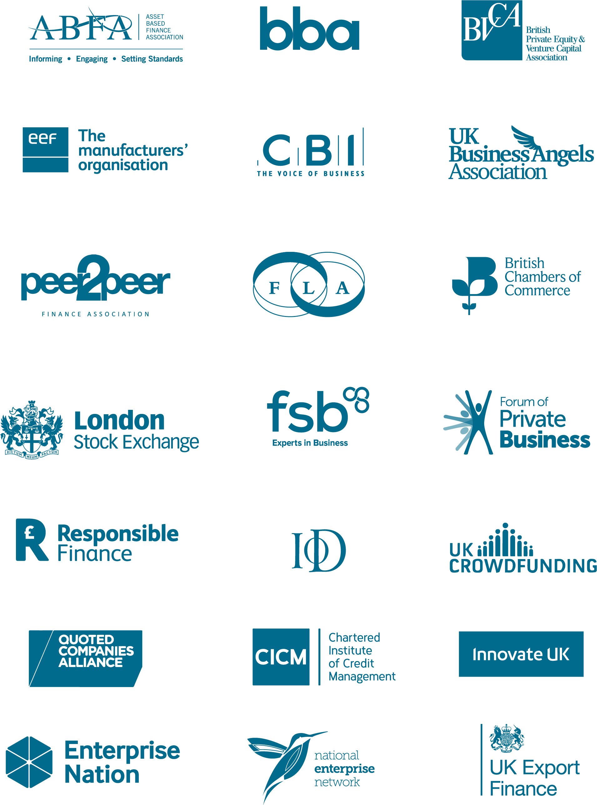

Foreword

Together on the journey
Since the British Business Bank and ICAEW’s Corporate Finance Faculty jointly published the first edition of THE BUSINESS FINANCE GUIDE in summer 2014, a growing number of alternative finance solutions have become more established, mainstream and accessible for the UK’s smaller businesses.
This increasing diversity of supply means smaller businesses should be able to exercise more choice when considering financing. Although our research shows businesses are becoming increasingly aware of their options, many others are still hampered in their ability to invest, grow and create jobs due to a lack of such awareness and understanding of their choices.
The first edition of THE BUSINESS FINANCE GUIDE made a good start in helping businesses become better informed. This edition draws on the considerable expertise of a wider range of partners from the finance industry and business community to provide information on forms of finance and where to find them – an essential starting point for businesses in selecting the most suitable options for their circumstances and plans.
As well as being a handy guide to leaf through, THE BUSINESS FINANCE GUIDE is now available online, offering enhanced content and interactivity that allows businesses to explore their financing options more easily. You can find the online version at thebusinessfinanceguide.co.uk.
If you are involved in advising businesses, I would encourage you to contact either the British Business Bank or ICAEW about becoming a distributor of this publication.
The British Business Bank was set up with the aim of making the UK’s finance markets work better for smaller businesses, and building awareness of finance options is a big part of that. I hope that this guide gives businesses the information they need to capitalise on the variety of available finance so that they can continue their journey to success.
Keith Morgan, Chief Executive, British Business Bank
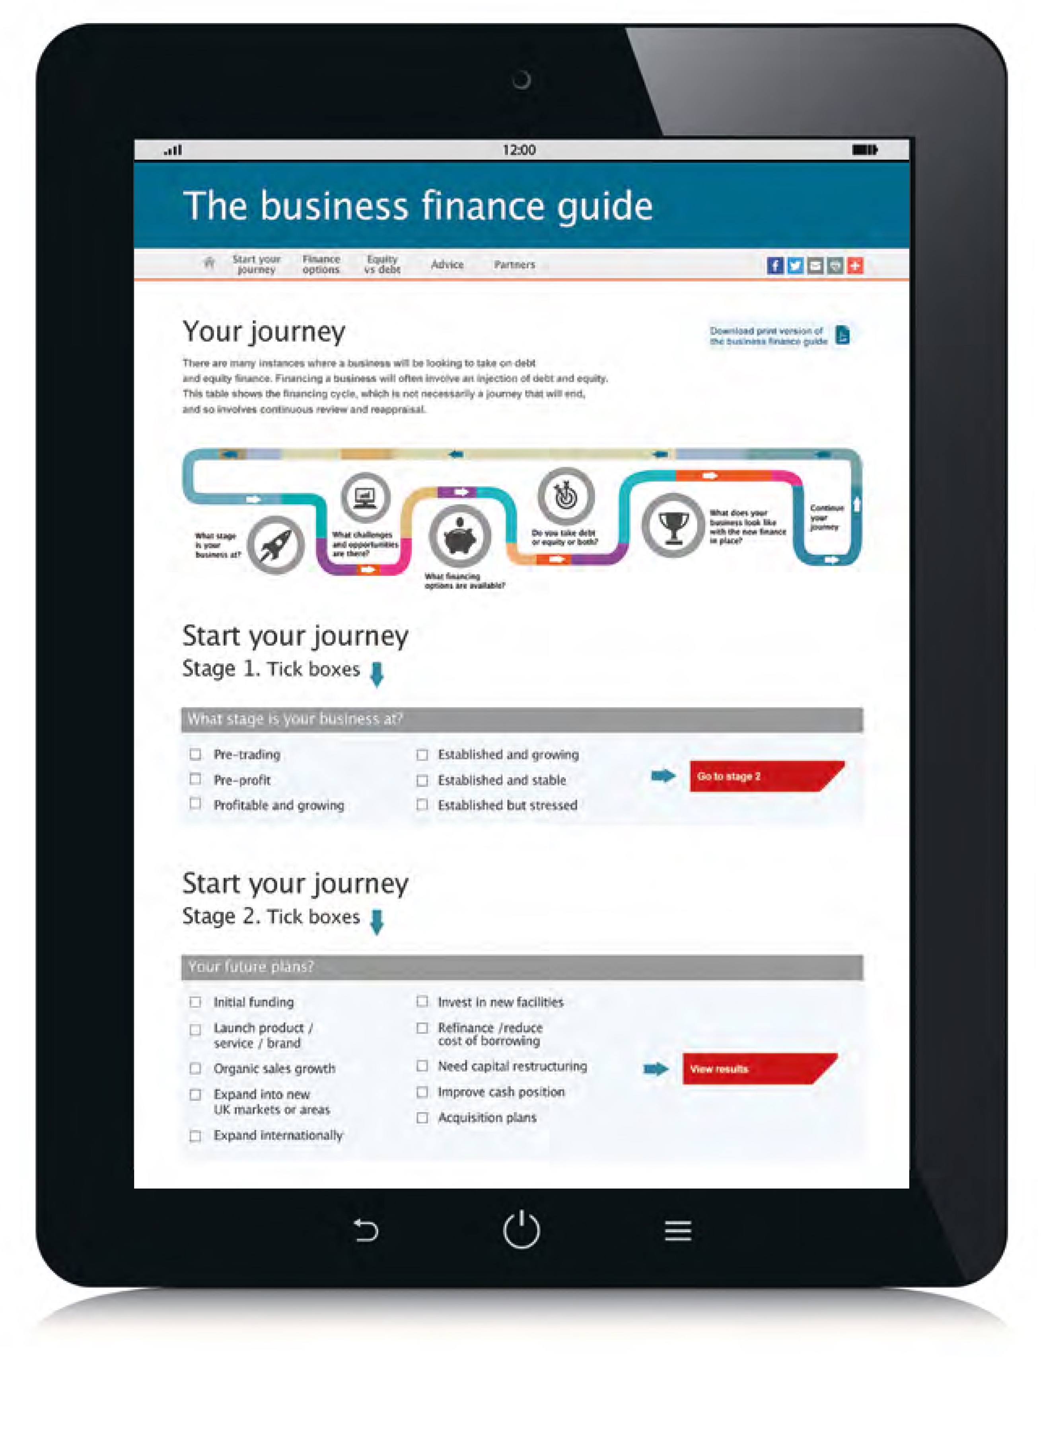
Begin your journey now. The online version of THE BUSINESS FINANCE GUIDE includes an interactive tool which will guide you through every stage of the financing journey.

Contents
Introduction 6
All in the prep 8
The journey 15
Know your options 19
Know your options: Equity finance 26
Know your options: Debt finance 44
Invest in advice 60
Find support 68
The British Business Bank 75

Introduction
Growing a business from the first seed of an idea is not a smooth linear journey and it’s not as simple as going from A to B. The destination is seldom decided as the business idea takes form, becomes a reality and then grows into a successful enterprise. The finance journey is continuous; there may never be an arrival point.
For any business to travel on a journey it needs at all points of that journey to be appropriately financed. Businesses need to make sure there is the finance to back their growth plans. Businesses are often started on overdrafts or credit cards, or with help from friends or family or by using the family property as collateral. But soon after that the business will need to be financed so it can stand on its own two feet if it is to be a sustainably growing proposition.
This guide will be invaluable for entrepreneurs who are starting a business, directors who are running growing businesses and established companies – of all sizes – as well as for business advisers and investors.
It explains how to approach the financing decision, the questions to ask and how to treat it as a business process, so that it is not as daunting as it can sometimes seem. And if it does get daunting, good advisers can provide further guidance. This guide also provides details of where to obtain free advice on raising finance.
Once a business is up and running on the growth journey, management will need to ensure that future plans for growth can be financed. If not, there is a chance the business will fail. The table on page 56 shows the options available to, and the decisions faced by, business-owners along that journey.
On the growth journey there will undoubtedly be ups and downs. Through the life of a business, as soon as plans are made, be they looking for growth or for survival or to batten down the hatches, the finance must be in place to support those plans.

All in the prep
The work to be done in getting a business to a position where it can take on additional capital need not be too daunting a task; however, nor should it be underestimated.
START by looking at the business afresh, with a questioning mind, so that the answers to the questions a potential shareholder or lender will probably raise are immediately to hand.
Step out from your business
Take a fresh look at prospects and challenges
Analyse your opportunities
Reach for the future
Think about finance

Step out from your business
Entrepreneurs want to focus on doing business. For many, finance falls under the category of administration, which may not be their forte. But to make sure the business can move forward entrepreneurs must step out from the business and ask the questions that need answering.

Take a fresh look at prospects and challenges
Plans may have been made when the business was little more than an idea. Things change and circumstances move on. You need to make a fresh assessment of where the business is, what the opportunities are, how achievable they are and what new challenges there are to the business.

Analyse your opportunities
You need to make a detailed analysis of the prospects for the business in light of any changed circumstances. A review of the new upsides and the new downsides needs to be carried out and the impact of them assessed, together with the probability of different scenarios.

Reach for the future
On the basis of the above analysis, prepare a detailed forecast, looking at the forecast profit and loss (P+L) account and balance sheet and then, crucially, at the cash flow, which will highlight how much capital needs to be put into the business to finance your latest plans.

Think about finance
You then need to think about the financing options for the business, how appropriate and how attainable they may be. To secure debt financing and/or investment, you need to make your business proposition clear and understandable to your target audience – with a business plan. At this stage a business is likely to require outside advice and experienced resource to ensure that it is ‘investment ready’ for potential investors, giving it the best possible chance to secure funding. Be open-minded. The funding landscape has developed considerably over recent years and there are a lot of options available – some are new and some have been around for some time.

Business plan
Preparing a solid business plan is the key to securing funding. A robust business plan helps potential lenders or investors understand the vision and goals of the business. It also brings focus to management’s understanding of the business strategy. It helps them understand the risks inherent in the strategy and the impact of any deviations from their plan – particularly when it comes to funding.
Information will depend on the target audience, but it should incorporate:
- an executive summary, highlighting the main points, designed to grab the attention of potential lenders or investors;
- details of key personnel, their responsibilities, skills and experience;
- market analysis of the company, its products or services and its competitors;
- details of current and intended client base;
- a marketing plan targeting new or existing customers;
- historical financial information covering the last three years of trading (if available) – accounts (audited if available), and key accounting ratios;
- cash-flow data, including information about standard payment terms and typical debt turn;
- financial forecasts for the next three to five years, presented as the historical information, and highlighting the key underlying assumptions;
- cash-flow forecasts covering the next two to three years (or in the case of a start-up or turnaround, until the business moves into profit), clearly highlighting the amount of funding required;
- how creditors, capital expenditure, debtors and stock will be managed over the forecast period;
- additional ‘flexed’ forecasts showing the impact of key downside scenarios, such as sales targets not being met or cost savings taking longer to come on stream, may also be included, or if required, must be included; and
- how equity investors can exit or refinance the business, and realise their investment.
It must be clear how much of the existing owner’s money is committed to the business. If a lender or investor thinks the existing owner does not have enough ‘skin in the game’, securing a loan or investment is likely to be more difficult, if not impossible. The business should consider whether investors would be eligible for tax reliefs (as described on page 32) and ensure that it communicates this in the business plan. The amount of any backing already received from other banks or investors must be clearly stated. This can demonstrate the attractiveness of the business as an investment.
If a business is looking for debt finance the plan needs to demonstrate how the business will be able to both meet interest payments and repay the capital element over the period of the loan. A repayment schedule linked to the forecasts will make this clear. And when looking for equity, the plan will need to show how the potential shareholder would receive dividends and how the value of the business and therefore their stake would grow.
The plan should always be ‘fully funded’ – with sufficient headroom so that the whole process will not have to be revisited too soon. Whether it is short-term debt finance or long-term growth capital, different equity investors and different debt providers will all have specific requirements when it comes to the content of business plans.
There is more detail on how to prepare a business plan on the websites of many of the contributors to this guide. Website details are on pages 68–74.
‘The best journeys in life are those that answer questions you never thought to ask.’ – Rick Ridgeway

Cash is king
Before looking for external capital, businesses should make sure they are managing cash effectively. Some fairly simple steps can help maximise available cash. Being able to demonstrate good cash management also sends out the right signals to potential investors or lenders.
The only way cash flow can be kept under control is by understanding the ins and outs. A weekly cash-flow forecast is often essential, particularly in a growing business.
Management must have an understanding of the amount of cash and working capital required to operate the business. Then working capital needs to be carefully managed. For example:
- stock and work-in-progress (WIP) levels must be reviewed, and excess stockholdings actively reduced;
- sales invoices must be issued in a timely manner and through best-practice credit management procedures, with payments collected within those terms;
- contractual agreements with suppliers should be reviewed to generate cash and suppliers paid to credit terms;
- capital expenditure should be carefully assessed and consideration given to the cash-flow implications of outright purchase; and
- automated payment methods should be used wherever possible – getting customers to pay by electronic transfer or through direct debit helps increase the speed and certainty of payment.
This approach to cash management is not just part of the preparation for taking on new investment or debt; it is a procedure that must be ongoing. With new stakeholders the scrutiny of cash flow will likely be even greater as the business’s journey proceeds.

The journey
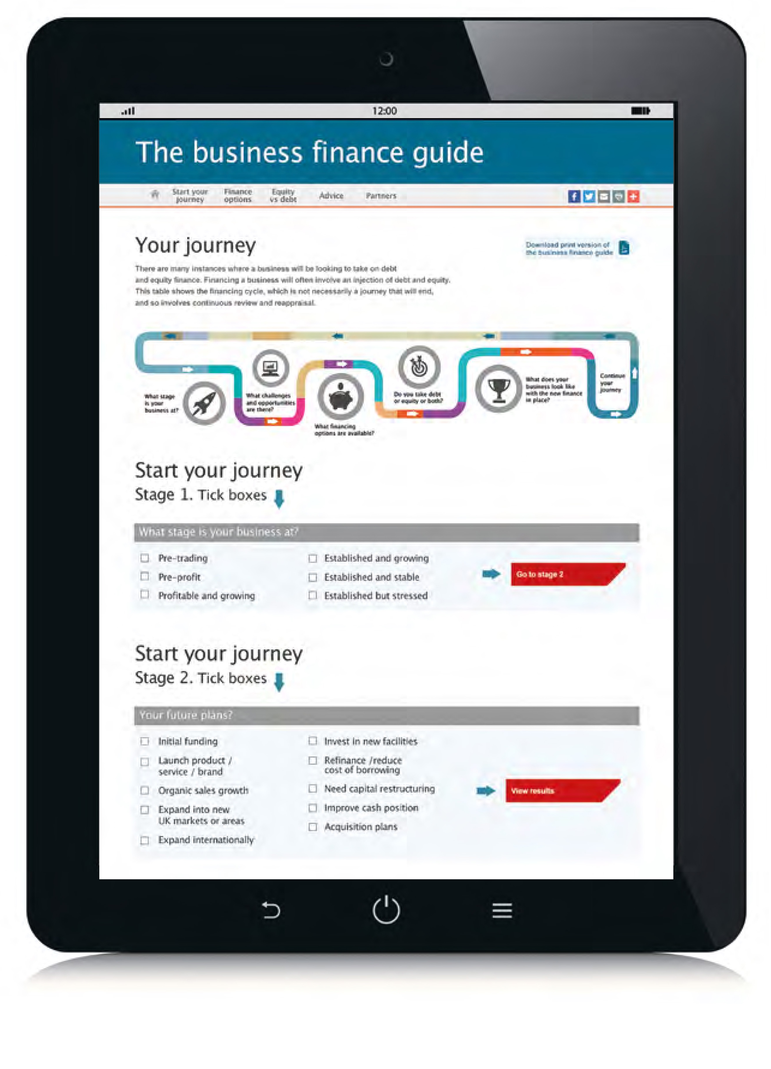
Financing a business will often involve an injection of debt and equity. This diagram shows the financing cycle, which is not necessarily a journey that will end, and so involves continuous review and reappraisal. Visit thebusinessfinanceguide.co.uk for a guide to every stage of the finance journey.

What stage is your business at?

- Pre-trading
- Pre-profit
- Profitable and growing
- Established and growing
- Established and stable
- Established but stressed

What challenges and opportunities are there?

- Initial funding
- Launch product/ service/brand
- Organic sales growth
- Expand into new markets or areas
- Expand internationally
- Invest in new facilities
- Refinance/reduce cost of borrowing
- Need capital restructuring
- Improve cash position
- Acquisition plans

What financing options are available?

EQUITY
- Seed finance
- Angel finance
- Equity crowdfunding
- Venture capital
- Corporate venture capital
- Private equity
- IPO/public offering
DEBT
- Start-up loan
- Overdraft
- Bank loan/bond
- Peer-to-peer lending
- Asset-based finance
- Leasing or hire purchase
- Export or trade finance
- Growth finance

Do you take equity, debt or both?


What does your business look like with the new finance in place?


Continue your journey


Know your options
For any entrepreneur, wherever they are on their business journey, knowing what options there are along the way is key to making successful progress. And, crucially, this applies to the financing options.
The idea that an exact route can be mapped out for a business is one road analogy too far. Running a business will throw up many new challenges: closed roads or roads that lead to dead ends, so being aware of the alternative routes is critical. You may need to take advice on directions but if you are forearmed with the knowledge that there are alternatives, the journey is far less daunting.
This table shows the various options commonly available at different business stages. Availability will, of course, depend on the circumstances of a business.
‘I have noticed that even people who claim everything is predestined, look before they cross the road.’ – Stephen Hawking
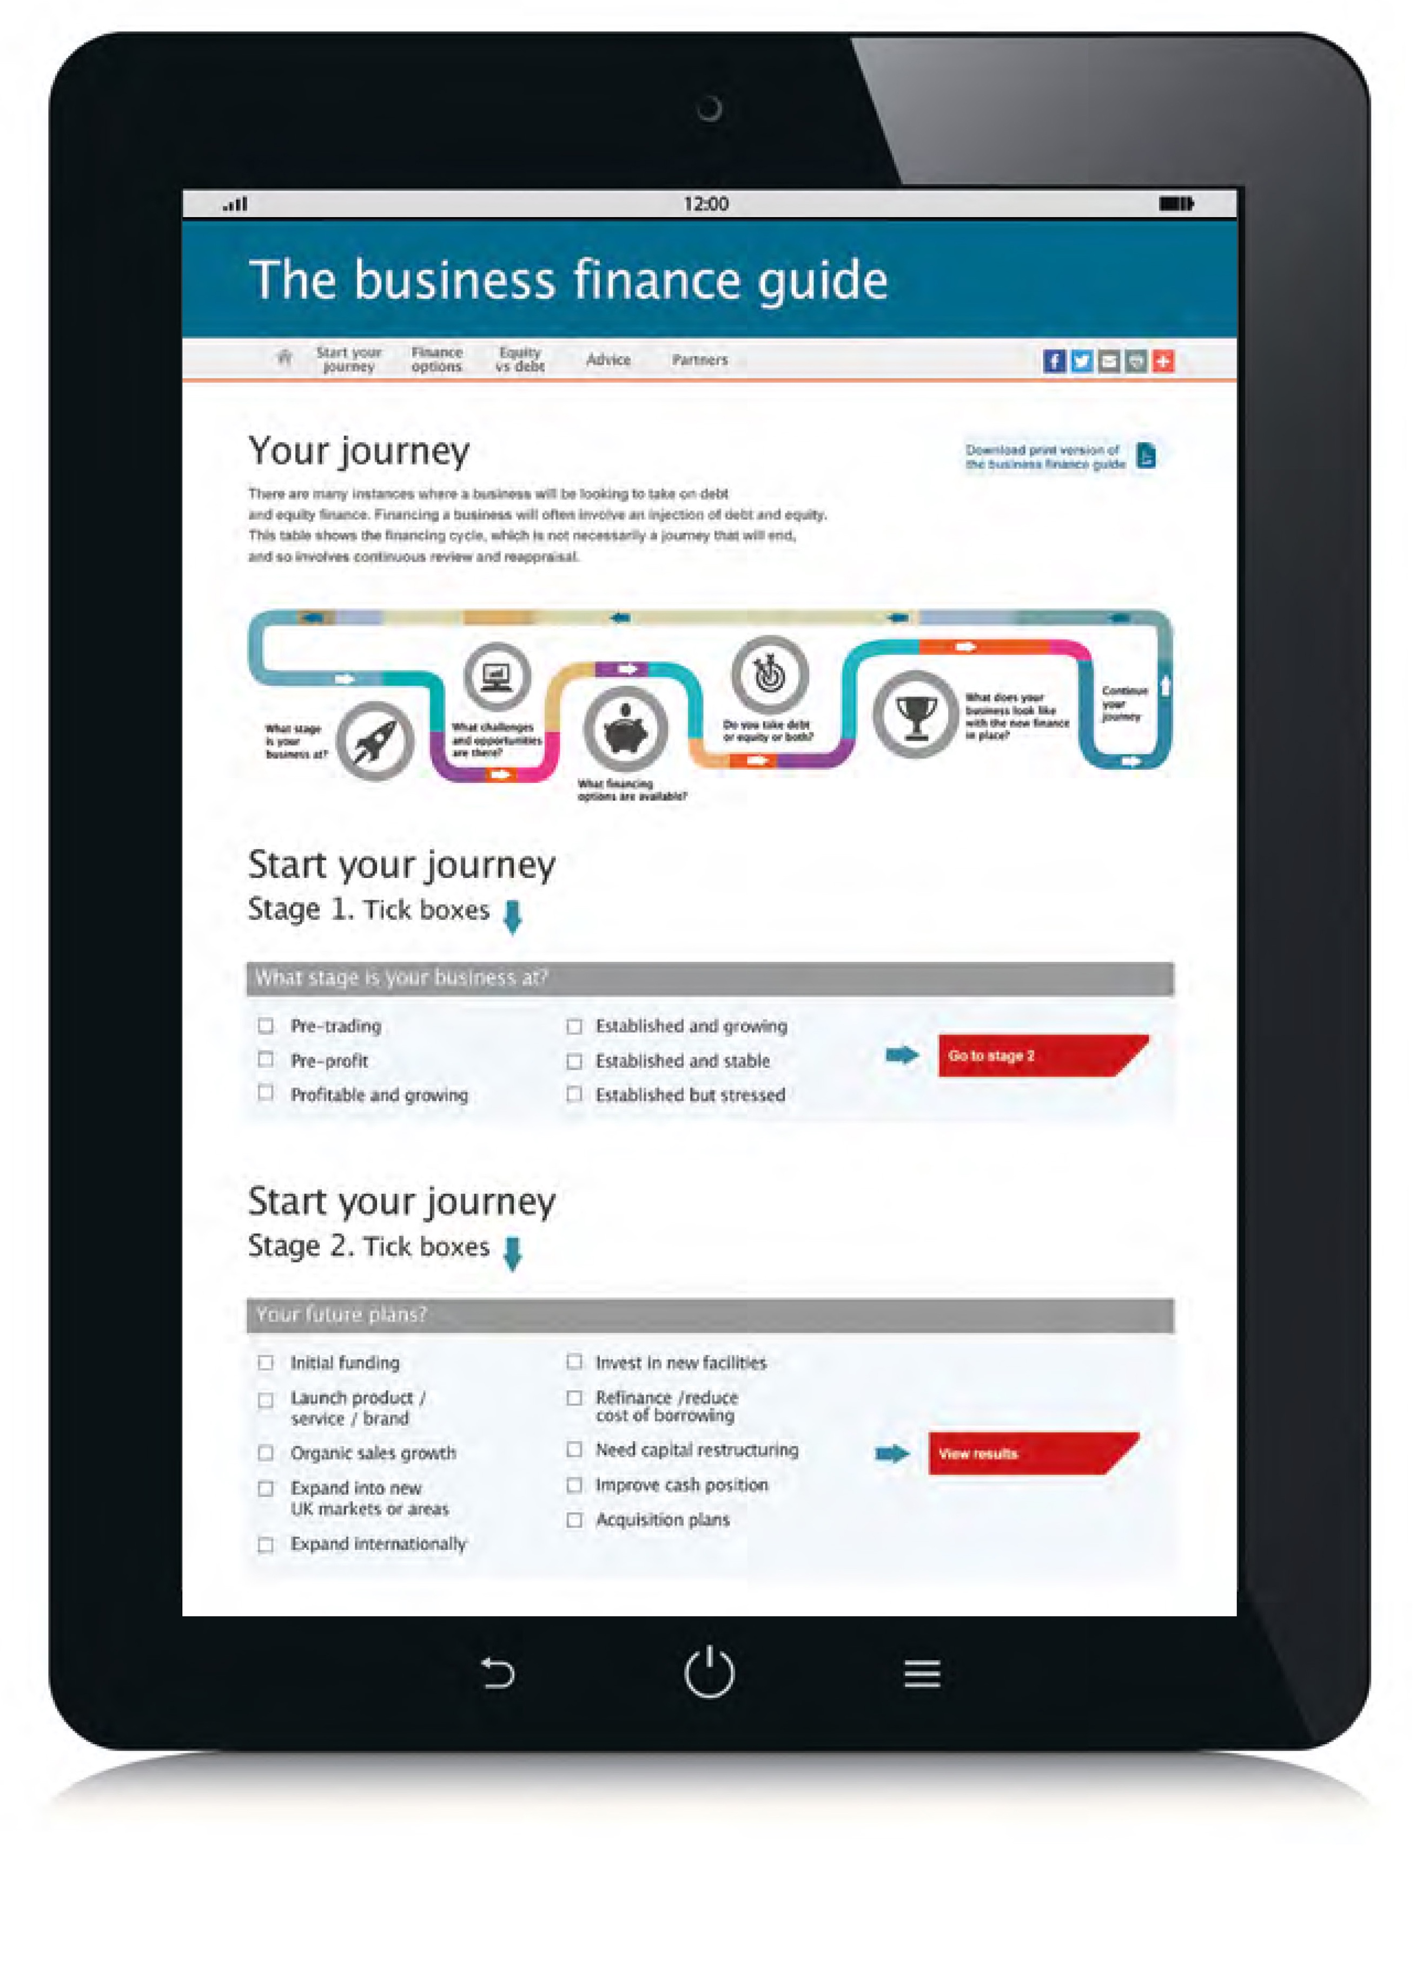
For a comprehensive description of all the financing options visit thebusinessfinanceguide.co.uk
 | Equity options (pp 26 to 43)
 | 1 | 2 | 3 | 4 | 5 | 6 | 7
What stage is your business at?
Pre-trading | ●
Pre-proﬁt | ● | ● | ● | ● | ●
Proﬁtable and growing |  | ● | ● |  | ● | ● | ●
Established and growing |  | ● | ● |  |  | ● | ●
Established and stable |  |  |  |  |  |  | ●
Established but stressed |  |  |  |  |  | ●
What future plans, challenges or opportunities are most important in your business right now?
Initial funding | ● | ● |  | ● | ●
Launch product/service/ brand |  |  | ● |  | ● |  | ●
Organic sales growth |  |  |  |  | ●
Expand into new UK markets or areas |  |  |  |  | ● | ● | ●
Expand internationally |  |  |  |  | ● | ● | ●
Invest in new facilities |  |  |  |  |  | ● | ●
Reﬁnance/reduce cost of borrowing |  |  | ●
Need capital restructuring |  |  | ●
Improve cash position |  |  | ●
Acquisition plans |  |  |  |  |  | ● | ●
Key: 1 - Seed ﬁnance; 2 - Angel ﬁnance; 3 - Equity crowdfunding; 4 - Venture capital; 5 - Corporate venture capital; 6 - Private equity; 7 - IPO/public offering.

 | Debt options (pp 44 to 59)
 | 1 | 2 | 3 | 4 | 5 | 6 | 7 | 8
What stage is your business at?
Pre-trading | ●
Pre-proﬁt | ● | ● |  |  | ● | ● | ● | ●
Proﬁtable and growing |  | ● | ● | ● | ● | ● | ● | ●
Established and growing |  | ● | ● | ● | ● | ● | ● | ●
Established and stable |  | ● | ● | ● | ● | ● | ●
Established but stressed |  | ● | ● |  | ● | ● | ●
What future plans, challenges or opportunities are most important in your business right now?
Initial funding | ●
Launch product/service/ brand | ● | ● | ● |  | ● |  |  | ●
Organic sales growth |  | ● | ● | ● | ● |  | ● | ●
Expand into new UK markets or areas |  |  | ● | ● | ● |  | ● | ●
Expand internationally |  |  | ● | ● | ● |  | ●
Invest in new facilities |  |  | ● | ● |  | ●
Reﬁnance/reduce cost of borrowing |  |  | ● | ● | ● | ●
Need capital restructuring |  |  | ● | ● | ●
Improve cash position |  |  |  |  | ● | ● |  | ●
Acquisition plans |  |  |  |  |  | ●
Key: 1 - Start-up loan; 2 – Overdraft; 3 - Bank loan/Bond; 4 - Peer-to-peer lending; 5 - Asset-based ﬁnance (includes asset-based lending, factoring, invoice discounting and supply chain finance); 6 - Leasing & hire purchase; 7 - Export or trade ﬁnance; 8 - Growth ﬁnance.

Know your options: Equity finance
You can look to equity investment as a way to finance many different stages of the business journey. Whether starting out or experiencing a high-growth phase, equity is an important part of finance arrangements for businesses and usually brings broader expertise with it.
It is also important to recognise that some investors can take a minority stake – not always a majority stake. Investors’ interests are aligned with the business, meaning all are on board for the growth journey.
The angels who backed my businesses, backed me from an early stage, through international expansion, all the way through to flotation. We could not have made that journey without them.’ – Sherry Coutu, CBE
At an early stage, businesses will need long-term backing to fund the business through to revenue and profit – this could be through business angels and/or venture capital and is commonly in different rounds with different parties. In the shorter term, equity investment can support an aggressive growth strategy.
In simple terms, equity financing is the raising of capital through the sale of shares in a business. Equity can be sold to third-party investors with no existing stake in the business. Alternatively, equity financing can be raised solely from existing shareholders, through a rights issue.

Think about the future
You need to consider several issues before selling a stake in your business in exchange for capital. Here are the main advantages to a business of different forms of equity finance.
- Equity funding is committed to the business and its intended projects, even if plans change.
- Equity investors take a risk acquiring shares. In exchange they can see uplift in the value of their stake if the business performs well, as a result of the deployment of that additional capital.
- Investors have aligned interest with the business towards the pursuit of its growth and success. Its growth and profitability will increase the value of the business and therefore their shareholding.
- As well as taking a stake in the business, the right angels, venture capital investors or any other equity investor can bring valuable resource to the business. Their skills, experience and contacts can help with the development of the business strategy.
- If it is a private company, the business owner can sell their stake privately to a willing private buyer, or if the business is to be listed they can sell their shares through the flotation.
- Investors are often prepared to provide follow-up funding as the business grows.
- Public equity raising provides a liquid market, which can be accessed if further fundraising is required for future growth plans.
- Equity crowdfunding provides a company with wider access to capital providers among customers and the public.
- The crowdfunding process can be relatively quick and attract customers at the same time.
Founding shareholders will have put the initial equity into the business. Friends or family may have ‘invested’ in the early stage of a business’s journey. Business angels may then take an equity stake. Venture capital (VC) investors, (also known as venture capitalists), corporate venture capitalists or private equity (PE) investors tend to be an option at the growth phase. Financial institutions or the wider public may invest in equity through a listing of the company’s shares. The public may also acquire equity stakes through equity crowdfunding platforms. In reality, it is not quite that simple – business angels, for instance, may invest at many stages in the business’s growth. As it progresses, a company’s shareholder register will be a mix of investors who have taken stakes at different stages of its journey.
Unlike debt providers, or lenders, (see the debt finance section on page 44), equity investors do not have rights to interest, or to have their capital repaid by a certain date. Shareholders’ return is usually paid in dividends or realised through capital growth. Both are dependent on the business’s growth in profitability, and its ability to generate cash. Because of the risk to their returns, equity investors will expect a higher return than debt providers. Where a project requires longer-term investment than conventional debt offers, equity will be the most suitable form of finance.
There is also a hybrid of debt and equity finance – mezzanine. Mezzanine and growth capital loans are covered under growth capital in the debt finance section.
Other considerations for businesses looking for equity investment.
- Raising equity finance can be costly. It demands management time, which may be diverted from the day-to-day running of the business.
- Potential investors will scrutinise past results and forecasts of future performance, and will investigate background information, including that of the management team.
- The owner’s share in the business will be diluted. And once the new shareholders invest, management will face varying degrees of influence when making major strategic decisions, of course depending on the nature of the shareholding and the stake acquired.
- Management time will need to be invested in producing regular information for the investor to monitor.
- There can be legal and regulatory requirements to comply with when raising equity finance.
- There are more disclosure and governance requirements if a company raises capital from public markets.
- Crowdfunds are normally ‘fill or kill’ – if a proposition does not hit its target it receives no investment at all.
- Dividend payments are not deductible for tax purposes.

Business angels
Business angels are individuals who make equity investments in businesses with growth potential, businesses in the early stages of development, or in established businesses looking for expansion capital. Angels back high-risk opportunities, with the potential for high returns.
Some invest on their own, others through an angel syndicate or club. However, the most significant trend is for angels to invest in syndicates or groups, generally with a lead angel. At seed stage, lower amounts of funding may be available. Businesses in the growth stage may be able to attract higher amounts from angel syndicates. Angels can offer multiple rounds of finance and frequently co-invest with other sources of equity and co-investment funds as further growth finance is required.
When taking on angel investment, a business should look beyond the capital they put in. Most angels can bring valuable first-hand experience of growing businesses, often early-stage businesses. Their skills and experience will be shared with the business, as well as their network of contacts. Most focus on investments within a small geographic area, and so have local knowledge and local networks. Angels often make investment decisions quickly, without complex assessments. However, tracking down the right angel can take time.
Find out more through the UK Business Angels Association, ukbusinessangelsassociation.org.uk.

Venture capitalists
Venture capitalists invest in businesses with the potential for high returns – those with products or services with a unique selling point, or competitive advantage. They invest in a portfolio where a significant number of businesses may fail, so those that succeed have to compensate for those losses. They also want proven track records, and so rarely invest at the start-up stage. Like angel investors, venture capitalists bring a wealth of experience to the business. They are unlikely to get involved in the day-to-day running of the business but will often help focus the business strategy.
Securing VC investment can be a complex, costly and time-consuming process. A detailed business plan is a must. And legal fees will be incurred through the deal negotiation, regardless of whether investment is ultimately secured.
Corporate venture capital (CVC) is another growing source of funding for small businesses. It describes a wide variety of equity investment undertaken by a corporation, or its investment entity, into a high-growth and high-potential, privately-held business. CVC performs the same economic role that private venture capital plays – the identification and nurturing of the innovative businesses of the future. This formal and direct relationship is usually three-fold: by making a financial investment in return for an equity stake in the business; by offering debt finance to fund growth activities for an agreed return; by offering non-financial support for an agreed return, such as providing access to established marketing or distribution channels, or knowledge transfer. It is important that the corporation’s aims are aligned with those of the business.
Find out more through the BVCA (British Private Equity & Venture Capital Association), bvca.co.uk, as well as its dedicated website on venture capital – venturecentral.co.uk.

Helping hand from HMRC
When taking on equity, businesses should make potential investors aware of four HMRC schemes. These encourage investment in unlisted growth companies, through a range of tax reliefs against investment in new shares.

Seed Enterprise Investment Scheme (SEIS)
At the time of the new shares being issued, start-up companies eligible to receive investment through the SEIS must:
- employ fewer than 25 full-time equivalents;
- have less than £200,000 of gross assets; and
- not have had any EIS or VCT investment.
Companies can receive a maximum of £150,000 under an SEIS.

Enterprise Investment Scheme (EIS) and Venture Capital Trust (VCT) Scheme
Businesses eligible to receive investment through the EIS or VCT schemes must, at the time of the capital raising:
- employ fewer than 250 full-time equivalents, (500 for ‘knowledge-intensive’ companies);
- have less than £15m of gross assets, and no more than £16m after the capital raising;
- not be listed on a recognised stock exchange, such as the London Stock Exchange, (but AIM listed companies are permissible); and
- be carrying on a ‘qualifying’ trade.

Social Investment Tax Relief (SITR)
Social enterprises eligible to receive equity (or with certain restrictions debt), investment through the SITR scheme must, at the time of the capital raising: have less than £15m of gross assets, and no more than £16m after the capital raising; and
- employ fewer than 500 full-time equivalents;
- have less than £15m of gross assets, and no more than £16m after the capital raising; and
- not be listed on a recognised stock exchange, such as the London Stock Exchange, (but AIM listed companies are permissible).
There are further requirements, which the company or social enterprise must meet for a continuous period from the issue of the shares, (or debt if raised through the SIRT scheme).
Companies can raise a maximum of £5m in any one year, and £12m in total, from these four schemes, (or £20m for ‘knowledge-intensive’ businesses).
For full details of the latest range of tax reliefs visit hmrc.gov.uk.

Private equity
PE makes medium- to long-term investments in, or offers growth capital to, companies with high-growth potential. PE investors would usually improve the profitability of the business through operational improvements and aim to grow revenue through investment in product lines or new services, or expansion into new territories. They will also typically introduce corporate disciplines and a management structure to the business, to give it a platform on which it can grow further. The PE model of governance consists of the combination of strategic, financial and operational expertise. The provision of non-financial support includes facilitating access to established marketing or distribution channels. PE investors would actively manage their investment through a period of five to seven years on average. After this they would exit their investment, selling their shares, having seen the value of the invested company grow. A PE firm may sell their stake to another PE firm or a corporate trade buyer. Alternatively, it may publicly list the company.

Equitable questions for an equitable outcome
Before seeking equity finance, consider these five questions:
1. How much is required?
2. What is it for?
3. How long will the funds be needed for?
4. What other skills does the business need?
5. What level of control do existing shareholders want to retain?
The answers can be incorporated in a comprehensive business plan, which should incorporate realistic financial projections, a detailed marketing plan and, crucially, what the investor can expect in return.
Networking and making use of any suitable contacts is critical to finding appropriate potential investors. Many corporate finance advisers will have networks of contacts in the business angel, VC and PE communities. Engaging an adviser can help the process.
Many private investors focus on specific industry sectors or geographical areas. The following associations may help you to track down investors, networks or networking opportunities:
- the UK Business Angels Association – see ukbusinessangelsassociation.org.uk;
- the BVCA – see bvca.co.uk; and
- Invest Europe (formerly the European Private Equity and Venture Capital Association (EVCA)) – see investeurope.eu.

Equity crowdfunding
The use of equity crowdfunding by companies looking to raise equity finance is becoming increasingly common. In effect it is a means to connect companies with potentially hundreds of thousands of potential investors, some of whom may also be current or future customers. It does this by matching companies with would-be angels via an internet-based platform.
Raising equity finance through crowdfunding platforms can be an alternative to seeking angel or VC finance through more traditional routes – for start-up, early-stage and growth companies.
Before putting a pitch for equity investment on a crowdfunding platform, you would need to show that your business is investment-ready. As with attracting traditional angel or VC investment, you would need to produce a business plan and financial forecasts. A business might also include a video summarising the opportunity.
The fees payable for raising equity finance on the crowdfunding platform will typically be a success fee and legal fees related to the issue. You may incur additional legal and advisory fees in the preparation of the pitch. Limited due diligence is usually carried out by the platform and the investor may have the option to ask for more information. Although the investment will be listed on the platform, investors will not be advised to invest in a particular equity offering.
The three main models are:
- pure crowdfunding, where every investor is equal and every one becomes a direct shareholder;
- angel-led crowdfunding: where one experienced investor leads the round, negotiating the terms and due diligence, and the crowd follow; and
- crowdfunding with a nominee structure, where the platform plays an ongoing role representing their crowd investors’ interests by appointing a single nominee.
Equity crowdfund raisings can be eligible for SEIS or EIS relief (see box on pages 32-33).
Equity crowdfunding is regulated by the Financial Conduct Authority (FCA).
Some crowdfunding platforms offer both equity and debt finance.
Find out more on the UK Crowdfunding Association website, ukcfa.org.uk.
The British Business Bank is encouraging diversity and competition in equity investment markets for smaller UK businesses by committing capital to investment funds. It does this through the following funds.
Enterprise Capital Funds are commercially-focused funds that bring together private and public money to make equity investments in high-growth businesses. The investment encourages venture capital funds to operate in a part of the market where smaller businesses are not able to access the growth capital they need.
The Venture Capital Catalyst Fund invests in commercially viable venture capital funds that might otherwise fail to reach a satisfactory ‘first close’.
The UK Innovation Investment Fund (UKIIF) supports the creation of viable investment funds targeting UK high-growth technology-based businesses.
The British Business Bank is also investing alongside business angels via the Business Angel Co-Investment Fund (Angel CoFund), which supports businesses with strong growth potential.
Further information on these and other British Business Bank solutions can be found at british-business-bank.co.uk.

Public listing
The next stage of growth for a business may involve applying for a public listing of its shares.
The UK markets are the London Stock Exchange’s Main Market, AIM and the ICAP Securities and Derivatives Exchange (ISDX). Going public is a major milestone in a company’s journey.
The process of listing is time-consuming and involves a range of advisers, but it is an opportunity for a company to critically examine itself. The decision to launch an IPO (initial public offering) or flotation must be based on a realistic assessment of the business, its management, where it is in the stage of its development and its prospects.
A listing may be used to raise money to:
- finance growth opportunities;
- finance acquisitions;
- rebalance the balance sheet;
- broaden the company’s shareholder base; or
- provide liquidity at listing or when it comes to trading shares in the company.
The London Stock Exchange’s Main Market provides companies with access to Europe’s deepest pool of capital as well as the key benefits of higher profile and liquidity.
For commercial trading companies, there are three types of listing on the Main Market. First there is Premium or Standard Listing. The former has stricter requirements, such as a 25% free float but both need a three-year trading record. High-growth businesses that may be ineligible for Premium Listing can also access capital via the High Growth Segment, which requires a 10% free float and gives eligible companies the opportunity to fund their growth while preparing for an official listing in time.
A listing on the Main Market offers companies:
- access to a robust, real-time share price;
- access to deep pools of capital;
- benchmarking through the FTSE UK Index Series; and
- high profile through media coverage, investment research and announcements.
Find out more at londonstockexchange.com.
In addition, a public listing will increase the profile of the company with a wide range of stakeholders, including customers, suppliers and peers, and allow it to incentivise key employees through share option plans more easily.
If your business has a trading track record and further growth plans, it would be in a position to raise equity capital through an IPO (flotation). A proportion of its shares would then be listed on a stock exchange and traded in the secondary market. An IPO is the sale of shares to institutional and larger investors and, sometimes, the general public.
The run-up to a company seeking a listing can be broadly divided into two phases – pre-IPO preparation and the IPO process itself. Pre-IPO preparation includes the critical review of a company’s business plan and growth prospects, assessing the management team, appointing an appropriate board, tightening internal controls, improving operational efficiency and resolving issues that may adversely affect the listing early on.
A company should bear the following in mind.
- The management team will need to be able to explain the business, its strategy and prospects clearly to investors, and demonstrate knowledge of the market as well as its challenges.
- A comprehensive business plan will be needed, which will set out the products, markets, competitive environment, strategy, capabilities and growth objectives.
- The company’s financial performance should preferably be one of consistent top- and bottom-line growth, with a sound balance sheet post-IPO.
- A financial model should demonstrate clearly the company’s growth prospects and associated risks to give investors confidence.
- If the company is raising new capital, the use of proceeds should be clearly articulated and in line with strategy.
- Proper financial controls need to be in place.
- A publicly-listed company will need to clearly articulate its corporate governance arrangements to demonstrate it has a board capable of running a public company.
The IPO is a step in a company’s growth cycle and the start of its life as a public company, which will make certain ongoing demands on the business. Financial statements must be produced and corporate governance codes adopted to provide a framework for long-term engagement with shareholders. Quoted companies are subject to shareholder monitoring, as their shareholder base is likely to change more often, and there is always the possibility of a change of control. Generally, the actions of the company will come under far greater scrutiny, as one would expect when its shareholder base is spread wider and the public can potentially own shares in it. For many management teams this may be viewed as preferable to having a smaller number of more dominant private shareholders.
Investor relations (IR) activity is the term used to describe the ongoing communication a company would have to undertake with the investment community. It is a mix of regulatory and voluntary activities and is essentially part of the public life that sees listed companies interact and raise their profile with existing and potential shareholders, analysts and journalists, customers and suppliers, and disclose information on new developments. IR activity requires a planned and strategic approach.
Once on market, the company will have access to further equity capital, through a further issue or placing, should it need additional finance on its journey.
AIM is London Stock Exchange’s market for smaller growing companies. AIM has less prescriptive eligibility and ongoing requirements than the Main Market and enables earlier stage businesses, including those with angel and venture capital backing, to benefit from a flotation on a public market. It provides a global platform for these businesses to raise their profile and gain access to permanent capital.

ISDX is a London-based stock exchange providing UK and international companies with access to European capital through a range of fully-listed and growth markets.
The ISDX Growth Market is a source of equity finance for small- and mid-cap companies coming to a public market for the first time, as well as for existing issuers to raise further funds. Its admission process and ongoing regulation are designed to meet the needs of smaller companies.
The ISDX Main Board is an EU Regulated Market serving the needs of companies and other issuers seeking cost-effective admission to trading through the UKLA’s Official List or other European Competent Authority.
isdx.com

Know your options: Debt finance
Just as short-term capital should not be used to fund long-term plans, so the reverse is true. On the financing journey it is highly likely that you will need both, and the task is to get the mix right. Debt will undoubtedly be involved in growing a business. Debt comes in many different forms, each of which can be more or less appropriate to the type of business, the stage it is at in its development or the plans it has to grow. And often an established company will use a blend of different debt products from a range of providers.
Debt can be used for longer-term investment and/or to fund working capital. For the former, a loan, leasing arrangement or bond can be more appropriate and for the latter, some form of overdraft or asset-based finance (ABF) is likely to be more appropriate. At any stage of its development a business is likely to need a mix of different forms of debt. All have their advantages for different aspects of a business’s growth plans.
Debt, in its simplest terms, is an arrangement between borrower and lender. A capital sum is borrowed from the lender on the condition that the amount borrowed is paid back in full either at a later date (a bullet repayment), multiple dates, or over a period of time. Interest is accrued on the debt and the business’s repayment usually has an element of capital repayment and interest.
Unlike equity, debt does not involve relinquishing any share in ownership or control of a business. However, a lender is far less likely to help a business hone its strategy than a business angel or VC investor.
There are three broad categories of debt:
- loans and overdrafts;
- finance secured on assets; and
- fixed-income debt securities.
Loans from banks or other lending institutions primarily take the form of overdrafts or fixed-term loans. There are also peer-to-peer (P2P) business loans and start-up loans.
Finance secured on assets includes debt instruments such as asset finance (leasing or hire purchase) and ABF (invoice discounting, factoring, asset based lending (ABL) and supply chain finance). These are provided by most banks and specialist asset finance and ABF companies including some online platforms.
Fixed-income debt securities take the form of bonds or mini-bonds.
Credit unions are cooperatives that can offer loans to their members. Find out more at abcul.org/home. There are also community development finance institutions which provide micro-finance loans to start-ups and individuals as well as established enterprises. For further information visit findingfinance.org.uk.
What is most appropriate depends on the purpose of the capital being borrowed, the credit record of the borrower, the amount, the repayment term and the interest that is being repaid. You can see what is available from different providers at betterbusinessfinance.co.uk.

Overdrafts and bank loans
Overdrafts are often what a business uses to help finance working capital and to meet short-term requirements. Loans, leasing or hire purchase agreements are in most cases better suited to larger longer-term purchases, such as investment in plant and machinery, computers or transport.
While it is almost always the case that an entrepreneur will benefit from the knowledge, insight and network of advisers who deal day-to-day with banks and other finance providers, businesses themselves should cultivate relationships with banks and other finance providers, who may help meet future financing requirements rather than just the immediate needs.
To obtain a loan or overdraft, management must demonstrate to the lender that the business will generate the income and cash to both repay the facility according to the terms of the loan, and service the loan by meeting interest payments. Market conditions and regulatory requirements, such as those that mandate responsible lending to viable businesses, may also impact the ease with which a business can access a loan or overdraft.
It is likely that the business will need to provide security for any money borrowed against other personal or business assets. A lender may be able to access the Enterprise Finance Guarantee programme (see box on page 55).

Debt funds
Increasingly debt funds are offering to lend directly to businesses. This has been more targeted at larger businesses and has arisen in the wake of the financial crisis, as the funds have stepped in where banks have been forced to reduce the size of their lending book because of liquidity rules. The loan will typically be indistinguishable from a bank loan in relation to the terms. Often debt funds will co-lend alongside banks.

Peer-to-peer lending
One major innovation in the supply of debt to business is P2P business lending. This is where internet-based platforms are used to match lenders with borrowers. The UK is at the forefront of innovation in this growing form of alternative online finance.
P2P business lending is a direct alternative to a bank loan. It can often be more quickly arranged and it allows partners, customers and friends and family who invest through the platform to share in the returns of the business. Investors can lend small parts of individual loans, for very small amounts, which encourages a wide range of lenders to participate across multiple loans. P2P business loan sizes range from a few thousand pounds up to several million with the upper threshold increasing as the industry grows.
Platforms have set criteria to define which businesses can borrow through the platform. They usually require borrowers to have a trading track record, to submit financial accounts, and they perform credit checks as part of the credit assessment. Platforms offer either a fixed rate or, in some cases, lenders bid for loans by offering an interest rate at which they would lend. In this instance, borrowers accept loan offers at the lowest interest rate.
The FCA regulates P2P lending. P2P loans have been eligible to be held in Innovative Finance Individual Savings Accounts (IF ISAs) as of 6 April 2016.
Further information can be found on the Peer-to-Peer Finance Association website, p2pfa.info.

Asset finance
Leasing and hire purchase are types of finance used by businesses to obtain a wide range of assets – everything from office equipment to vehicles – and could be the perfect solution if you need new equipment which would otherwise be unaffordable because of cash-flow constraints.
Because leases and hire-purchase agreements are secured wholly or largely on the asset being financed, the need for additional collateral is much reduced. There is more security for the user because the finance cannot be recalled during the life of the agreement, provided the business keeps up with payments.
A leasing company buys and owns the equipment, which the business then rents for a predetermined period. The business also has the option to replace or update the equipment at the end of the lease period. Typically, the lease will have a set interest rate, which fixes the outgoings on that asset.
If a business wants to own the equipment at the end of the agreement, but avoid the cash flow impact of buying outright, then hire purchase is an option. A finance company buys the equipment and the business repays the cash price plus interest through regular repayments. These agreements are also normally at fixed interest rates. At the end of the agreement there is usually a nominal fee to acquire title to the equipment.
The accounting treatment of leases and hire purchase agreements are different. A chartered accountant will be able to advise on this.
Leasing and hire purchase are available directly from specialist providers, or indirectly through equipment suppliers or finance brokers.
Most of the firms providing asset finance in the UK are members of the Finance & Leasing Association (FLA) and all their agreements would be subject to the stringent standards set out in the FLA’s Business Code of Conduct. Find out more at fla.org.uk/asset.

Asset-based finance
ABF is a collective term used to describe invoice finance (IF) and asset-based lending (ABL). IF includes factoring and invoice discounting, which will both involve funding provided against outstanding debts.
IF can be used to support cash flow and release funding for investment by generating money against unpaid invoices. IF is available to businesses that sell products or services on credit to other businesses. The funding provided tracks the growth in the business – increasing turnover unlocks more funding.
Single invoice finance, where finance is raised against individual invoices, rather than turnover in total, is also available but is generally more expensive. P2P invoice finance platforms, which serve a broker function, are also increasingly playing a role in providing invoice financing.
- Factoring involves provision of finance through the purchase of invoices by the financier (the factor), representing the debts owed to the business. The factor will advance the majority of the value of the invoices on notification with the balance of the value made available once invoices are paid by the debtors. The factor works on behalf of the business – managing the sales ledger and collecting money owed by customers.
- In effect, factoring combines the provision of finance with a service element, helping the business with credit control, which can be particularly valuable for smaller businesses. Export factoring is also available to support businesses selling internationally.
- Factoring can be provided on a recourse or non-recourse basis. The latter incorporates protection for the business against bad debts.
- Invoice discounting is similar to factoring, however, the business retains control over the administration of the sales ledger. An invoice discounter would want to satisfy itself as to the quality of a business’s sales ledger systems and procedures. ID can also be used to support exports.
- Supply chain finance (also, reverse factoring) is where smaller suppliers can take advantage of the credit strength of their larger customers. Supply chain finance requires the involvement of the supplier and their customer and up to 100% of the value of invoices can be funded once they have been approved by the customer, often at more competitive rates than would otherwise be available. Supply chain finance can be accessed directly through some larger organisations and also through a growing number of alternative providers.
- In the past ABL has been seen as a more sophisticated product for larger small and medium-sized enterprises (SMEs) and mid-sized corporates, however it is now increasingly available for smaller businesses as well. ABL is usually provided on a similar basis to invoice finance, with funding being extended against debts, but in an ABL arrangement this is complemented by finance against a wider pool of assets, typically including stock, property, plant, machinery and also potentially intangibles such as intellectual property or forward income streams. ABL can be used in mergers and acquisitions, management buyouts and also turnarounds.
- Whereas invoice finance would ordinarily be provided on the basis of purchase of the debts outstanding, (and so in strict legal terms it cannot be correctly described as lending), ABL would normally involve taking additional security over the assets in question.
- As with any type of finance, it is important to get advice on the legal, financial and tax implications before entering into any agreement.

Weighing it up

Advantages of different forms of debt
- The terms can be tailored to suit the precise needs of the business.
- Repayments are straightforward, so can be simply planned for and the cash-flow impact budgeted.
- Generally, a loan costs less in interest than an overdraft over the same term.
- Interest is only paid on the amount of money used in an overdraft and the facility is only used if required – so they provide flexibility. Similarly, with invoice finance the equivalent of interest is only payable on the amount drawn down.
- There is tax relief on interest payments.
- Leasing gives a business access to the equipment they need without incurring the cash disadvantage of an outright purchase.
- Leasing is a flexible form of finance for all types of assets because the loans are secured wholly or largely on the asset being financed.
- P2P business lending can often be more quickly arranged than a bank loan.
- A wide range of lenders often participate in a P2P business loan.
- If businesses can apply online, applications can be made at any time of day without the need to visit a branch.

Other considerations
- Lenders will always take into account a potential borrower’s personal or business credit record when deciding whether or how much to lend.
- Loans are less flexible than overdrafts – charges could be payable on funds not used and there may be penalties for early repayment.
- Being locked into a rigid repayment schedule can prove problematic if cash flow is seasonal or erratic.
- Overdrafts are repayable on demand and so can be reduced or called in if the finance provider thinks that the business may be in difficulty. There are likely to be penalty charges for exceeding an overdraft limit.
- For larger amounts, security against the loan will almost always be required, as will personal guarantees from directors or owners.
- If a business is growing, the amount of asset-based finance will track the growth.
- Care should be taken when setting the repayment terms for a lease to ensure it is at least as long as the agreement.
- Interest rates in P2P business lending are often set by the market on the platform and reflect the level of supply of business loans.

The majority of providers of asset-based finance in the UK are members of the Asset Based Finance Association (ABFA). Businesses that use a member of the ABFA are covered by an independent Standards Framework; this includes a Code setting out the standards that can be expected and an independent Professional Standards Council. In addition, the majority of client businesses of ABFA members will also have access to an independent complaints process currently provided by Ombudsman Services. Further detail about the Standards Framework is available at: abfa.org.uk/standards. You can check whether a finance provider is a member of the ABFA at: abfa.org.uk/members/ memberslist.asp.

Merchant cash advances
These are unsecured advances of cash, based upon future credit and debit card sales. These are repaid via a pre-agreed percentage of a business’s card transactions. Unlike many other forms of business funding, company or personal assets are not required as security. If the cash advance takes longer to pay off, the originally agreed repayment cost remains the same.
Business Banking Insight (BBI) is an independent website which looks at how well the UK’s small and medium-sized businesses are being served by banks and other finance providers. First commissioned by the chancellor of the exchequer and now managed by the Federation of Small Businesses and the British Chambers of Commerce, the BBI website publicly showcases the experiences of more than 20,000 businesses. It shows how they rate their banks and finance providers, across a wide range of products and services. For more information visit: businessbankinginsight.co.uk.

Bonds and mini-bonds
Bonds – retail bonds or corporate bonds – are a way for companies to borrow money from investors in return for regular interest payments. They have a predetermined ‘maturity’ date when the bond is redeemed and investors are repaid their original investment. A lender is tied in until they mature. Bonds can have an advantage over loans in that the business issuing the bond can have more control over the specific terms of the finance.
Traditionally, corporate bonds and retail bonds would be traded on the stock market and really would only be available to larger companies which have a trading history. However, this is changing. Recently, crowdfunding platforms have entered the market, offering a one-stop-shop for raising finance through bonds. These platforms operate in a similar way to peer-to-peer lending platforms but offer the flexibility that bonds do, and generally work with larger amounts of funding (usually £1m upwards).
Mini-bonds are similar but, crucially, they are not traded on a stock market and can only be promoted to certain types of investor. A lender is also tied in until they mature.
The British Business Bank is enabling more effective and efficient debt finance markets for smaller UK businesses by providing guarantees on loans and loan portfolios, and by direct investment to support lending.
The Enterprise Finance Guarantee programme provides loan guarantees, encouraging lending institutions, including banks, to lend to viable smaller businesses that would otherwise be declined for lacking adequate security.
The ENABLE Guarantees programme provides guarantees on loan portfolios, helping lenders to unlock more lending to smaller businesses by enabling them to use their capital more efficiently, freeing up capacity.
The ENABLE Funding programme makes available cost-effective funding to asset and lease finance providers, helping them to increase their provision to smaller UK businesses.
The Help to Grow programme (pilot) works through partners to address the financing needs of smaller businesses which are struggling to raise sufficient senior debt to fund their growth opportunities.
Investment Programmes make commercial investments, which stimulate at least the same amount of investment from the private sector, encouraging new lenders into the market and the growth of smaller alternative lenders, such as P2P lenders.
The British Business Bank also has oversight of the funding provided to the Start-Up Loans Company to administer the programme. Start-up loans help people start their own business, filling the gap where lenders are less willing to finance new start- ups. They combine a low-cost loan with free first class mentoring and support, both pre-start-up and once the business is up and running.
startuploans.co.uk

Growth finance
Growth capital loans and mezzanine finance (growth finance) are flexible debt financing that are tailored to the specific risks in the business, with a repayment plan to match the forecast cash generation of the business. While they are a form of debt, both share many of the characteristics of equity. However, they rank below senior debt.
Both are most appropriate for financing high-growth businesses, and are typically used to finance the expansion of existing companies by VC investors – for product developments, penetration of new markets, infrastructure investments, or for strategic acquisitions. Basically debt capital, growth finance gives the lender the rights to convert to an ownership or equity interest in the company if the loan is not paid back in time and in full.
As they can be structured with low cash coupons they can reduce the cash burden, so are particularly suited for funding high growth, where senior debt may be less appropriate.

Export finance
When businesses export, they need to be sure they can afford to produce the goods and that they will be paid. Export finance helps mitigate risks such as default or delayed payment.
Manufacturers who import raw materials face other challenges. Overseas suppliers want to be paid for materials before shipping, so the need arises for finance to fill the gap between importing the raw materials and the point at which the finished product is sold. That’s where export finance comes in.
Export finance covers a wide range of tools, all used by banks to manage the capital required to allow international trade to take place as easily and securely as possible. Traditional tools are as follows.
- Bonds and guarantees – if the seller fails to deliver the goods or services as described in the contract, the buyer can ‘call’ the bond or guarantee and thereby receive financial compensation from the seller’s bank. The types of bonds and guarantees include tender guarantees, advance payment guarantees, retention money guarantees, performance guarantees and customs bonds.
- Letters of credit – these are issued by a bank, guaranteeing that the buyer’s payment will be received on time and for the correct amount, assuming the goods (or services) have been supplied as agreed. If the buyer is unable to pay any or the entire agreed amount, the bank will cover the shortfall. The bank also acts on behalf of the buyer – the holder of the letter of credit – by ensuring that the supplier will not be paid until the goods have been shipped.
UK Export Finance is the UK’s export credit agency and government department. It works to ensure that no viable UK export fails for want of finance or insurance by offering:
- free and independent guidance on sources of export finance;
- release of working capital with bank guarantees for credit facilities or contract bonds;
- security of payment with export credit insurance; and
- competitive finance packages for overseas buyers with buyer credit guarantees or direct loans.
The Export Working Capital Scheme assists UK exporters in gaining access to working capital finance in respect of specific export contracts. Find out more or book a consultation with an export finance adviser:
gov.uk/uk-export-finance.

Trade finance
Funding that assists businesses in purchasing goods, whether from international or domestic sellers, is termed trade finance. It is often transactional, with finance only being provided for specific shipments of goods and for specific periods of time. Here the asset being funded against is the goods themselves (as opposed to invoices in IF) and until repaid by the client, the goods belong to the finance provider. The process is supported by letters of credit, bills of exchange and bank guarantees.
‘On a journey of a hundred miles, ninety is but half way.’ – Chinese proverb

Invest in advice
Corporate finance advice along the business journey is critical. Remember that it is advice and that good independent advice is invaluable. Advisers have experience of many businesses, whereas entrepreneurs may just have experience of the one they are in.

Government sources of information
greatbusiness.gov.uk links to key sources of advice for businesses looking to grow, export and recruit.
gov.uk/business provides advice on starting, running, growing and financing a business, with an accompanying helpline available on:
- telephone: 0300 456 3565
- textphone: +44 (0)20 8742 8620.
gov.uk/business-finance-support-finder provides details on publicly supported finance, advice schemes, grants and loans.
The government’s Intellectual Property Office offers comprehensive guidance on using intellectual property to raise finance in its ‘IP Finance Toolkit’, which can be found at gov.uk/government/organisations/intellectual-property-office.

Business mentoring
Investment readiness may be the goal, but before a robust business plan can be prepared, the business may need access to knowledge and information so it can make the right finance choices.
Business mentors have both practical experience and a network of contacts to help businesses make the right choices. A mentor acts as an independent sounding board for ideas, provides guidance and support from a different perspective, and directs the business to the right areas for appropriate help.
The Enterprise Europe Network helps SMEs make the most of business opportunities in the EU and beyond. Its many services are offered free of charge by 600 member organisations, including chambers of commerce and industry, technology centres, universities and development agencies.
een.ec.europa.eu

Innovate UK is the UK’s innovation agency, and provides networking collaboration and funding opportunities, business-led innovation and R&D.
Innovate UK’s Smart funding scheme provides grants for start-ups and SMEs to help them develop their innovations – from proof-of-market through to proof-of-concept and on to prototype development. It provides grants of up to £250,000 per project.
You can find out more at: interact.innovateuk.org.
Innovate UK’s Knowledge Transfer Network (KTN) brings together businesses, entrepreneurs, academics and investors to network, collaborate and share information and ideas about innovative new products, processes and services. The KTN’s teams cover all significant sectors of the economy, from defence and aerospace to the creative industries, the built environment to biotechnology and robotics.
You can find out more at: ktn-uk.co.uk.

mentorsme.co.uk is an internet-based mentoring gateway linking UK businesses who are looking for a mentor with over 27,000 mentors. The British Bankers Association manages the portal, working with its mentoring partners and more than 1,000 volunteer bank mentors offering expertise in financial support. All mentors can be accessed through the website.

For businesses in the arts, cultural and creative sector that are seeking funding and investment, the ICAEW has published Creative Industries – Routes to Finance, with 52 organisations.
icaew.com/creativeindustries

ELITE is a London Stock Exchange programme and platform which facilitates engagement between private growth businesses, corporate advisers, investors and business leaders. The 18-month programme helps businesses with organisational review and change; executing the planned change; and accessing new business opportunities and funding. To be eligible for application, companies must: generate at least £5m in revenues; be able to demonstrate growth prospects; and require external investment.
For further information visit: londonstockexchange.com/elite.

Business coaching
Coaching can help a business produce its business strategy and financial plan. Presentation training is extremely useful in helping management present the company and their plans in the best possible light. It prepares them for the rigorous scrutiny of those plans by potential lenders or investors. At this stage an adviser would be comfortable introducing the company to a network of investors or lenders. Many independent advisory firms offer mentoring services.

Accelerators and incubators
There are now many business accelerators across the UK, which can be a valuable resource for start-ups. There are many different types of accelerator, often supported by the EU, national or local government, academic organisations and large businesses.
An accelerator provides advice, mentoring, practical and technical support to groups of new ventures often in return for a small equity stake in the business. Some accelerators will also invest equity capital or convertible loans. Others may take an option to acquire an equity stake at a later date.
Incubators are similar to accelerators – and mainly work in the science and technology sectors. These are ‘co-working’ spaces, where early-stage businesses are given guidance when developing concepts into commercial projects, whether they have been independently developed or spun out of academic, government or commercial organisations.
ICAEW’s Business Advice Service offers help to businesses in England, Scotland and Wales to overcome the challenges they face, including:
- how to grow a business;
- securing loans, capital and finance;
- keeping staff and creating new jobs;
- meeting tax and regulatory requirements;
- export planning;
- planning for long-term sustainable growth;
- debt management; and
- legal issues.
Businesses are offered a free advice session with an ICAEW Chartered Accountant. Visit businessadviceservice.com to find the nearest office participating in the scheme.
icaew.com

Business growth hubs
Growth hubs are public/private sector partnerships under the governance of the Local Enterprise Partnership (LEP). They bring together public and private sector partners to promote, coordinate and deliver business support. They provide a mechanism for integrating national and local business support, so it is easy for businesses to access.
Growth hubs aim to make it easier for businesses to start and grow, by ensuring business support is:
- simpler – providing a single local access point for all public and private sector business support;
- more joined up – local support is aligned with national programmes to improve coordination and reduce duplication of business support; and
- easier to access – through promotion of business support locally, assessing business’s needs, then connecting them with appropriate support; as well as enabling contact with other businesses for advice, support and mentoring. There are currently 39 growth hubs (one in each LEP area).
For a list of growth hubs visit:
lepnetwork.net/growth-hubs.

Support for businesses in Northern Ireland
Invest NI provides high quality services, finance programmes, support and expert advice to businesses. In addition, debt and equity support is provided through external FCA-approved fund managers. Visit investni.com to learn more.

Support for businesses in Scotland
Business Gateway provides a first point of contact for all publicly funded advice to business and is delivered through the local authorities. It offers a range of advice and support to new, established and growing businesses. Visit bgateway.com.
Visit mygov.scot/business for further information.
Businesses can also find out about finance options at mygov.scot/ways-to-fund-your-business.

Support for businesses in Wales
Business Wales provides support to people starting, running and growing a business. business.wales.gov.uk
Finance Wales makes commercial investments in SMEs based in – or willing to relocate to – Wales. Find out more at financewales.co.uk.

Local support for business across England
The government supports many local initiatives across England which help smaller businesses grow and access finance. You can find out what is available in your area by contacting your nearest Local Enterprise Partnership through the LEP network website, lepnetwork.net.
‘We don’t receive wisdom; we must discover it for ourselves after a journey that no one can take for us or spare us.’ – Marcel Proust

Find support

Asset Based Finance Association (ABFA)
The ABFA represents the invoice finance and asset-based lending industry in the UK and the Republic of Ireland. ABFA members include bank and non-bank finance providers, and the industry specialises in supporting businesses in the real economy. The ABFA has established a standards framework for the industry which independently sets and enforces the standards that can be expected from ABFA members.
abfa.org.uk

British Bankers’ Association (BBA)
The BBA is the UK’s leading association for the banking sector, representing the interests of more than 240 member organisations of all shapes and sizes, including retail banks, wholesale institutions, challenger banks and private banks, with a worldwide presence in 180 countries.
Better Business Finance is managed by the BBA in collaboration with its business and finance partners. It provides impartial information and support to business and entrepreneurs looking to develop and grow, whether the business is seeking finance, starting out or exporting abroad.
bba.org.uk betterbusinessfinance.co.uk mentorsme.co.uk

British Chambers of Commerce (BCC)
The BCC sits at the heart of a network of 52 accredited Chambers of Commerce across the UK, and a global business network. In the UK it brings together over 70,000 member businesses, and engages with a further 200,000 non-member companies each year. Overseas, its Global Business Network offers practical, on-the-ground help to UK exporters, and supports two-way trade.
britishchambers.org.uk

BVCA
The BVCA is the industry body and public policy advocate for the private equity and venture capital industry in the UK. Its membership comprises more than 600 influential firms, including over 250 private equity and venture capital houses, as well as institutional investors, professional advisers and service providers.
bvca.co.uk

CBI
The CBI is the UK’s leading business lobbying organisation, providing a voice for employers at a national and international level.
cbi.org.uk

Chartered Institute of Credit Management (CICM)
The CICM is Europe’s largest credit management organisation, and the second largest globally. The trusted leader in expertise for all credit matters, it represents the profession across trade, consumer and export credit, and all credit-related services. Formed more than 70 years ago, it is the only such organisation accredited by Ofqual and it offers a comprehensive range of services and bespoke solutions for the credit professional as well as services and advice for the wider business community, including the acclaimed CICM/BIS Managing Cashflow Guides.
cicm.com

EEF
EEF is the manufacturers’ organisation, helping thousands of companies to evolve, innovate and compete in a fast-changing world. It has a unique combination of business services, government representation and industry intelligence, and provides skills, knowledge and networks to enable companies to thrive.
eef.org.uk

Enterprise Nation
Founded by Emma Jones MBE in 2005, Enterprise Nation is a small business network with a community of more than 75,000 entrepreneurs, experts and business owners. Its aim is to help people turn their good ideas into great businesses. Members benefit from: a programme of 200+ online and offline events per year; access to expert advice; the latest small business news; a library of resources; and a strong and respected campaigning voice on the subjects that matter, from digital skills to exporting.
enterprisenation.com

Federation of Small Businesses (FSB)
The FSB is the UK’s largest campaigning pressure group, promoting and protecting the interests of the self-employed and owners of small firms.
fsb.org.uk

Finance & Leasing Association (FLA)
The FLA is the leading trade association for the asset, consumer and motor finance sectors in the UK, and the largest organisation of its kind in Europe. Its members include banks, subsidiaries of banks and building societies, finance arms of leading retail manufacturing companies and a range of independent firms.
fla.org.uk
‘Good company in a journey makes the way seem shorter.’ – Izaak Walton

Forum of Private Business
The forum is a not-for-profit membership organisation, which offers a one-stop-shop business support service, focused on the growth and profitability of small businesses.
fpb.org

Innovate UK
Innovate UK is the UK’s innovation agency, and provides networking, collaboration and funding opportunities, business-led innovation and R&D.
interact.innovateuk.org

Institute of Directors (IoD)
The IoD has been supporting businesses and the people who run them since 1903. As the UK’s longest-running organisation for professional leaders, it is dedicated to supporting its members, encouraging entrepreneurial activity and promoting responsible business practice for the benefit of the business community and society as a whole.
iod.com

London Stock Exchange
The London Stock Exchange Group is the largest stock exchange in Europe and the fourth largest in the world. It operates a range of equity and bond markets including AIM, the Main Market and Order Book for Retail Bonds (ORB). It also operates ELITE, a business support and education programme for high-growth private companies.
londonstockexchange.com

National Enterprise Network
National Enterprise Network is a unique membership body representing those working in the enterprise support sector across England. Its members provide a wide array of support to new and established businesses, offering impartial and independent information, advice, training and other services including loan funding, managed workspace and incubation facilities. National Enterprise Network’s online directory has been specifically devised to help people looking for core support in starting up, to put them in touch with support organisations located nearby.
nationalenterprisenetwork.org/findbusinesssupport

Peer-to-Peer Finance Association (P2PFA)
The P2PFA is the industry association representing debt-based alternative finance providers operating through electronic platforms.
p2pfa.info

Quoted Companies Alliance (QCA)
The QCA is the independent membership organisation representing the interests of small- to medium-sized quoted companies.
theqca.com

Responsible Finance
Responsible Finance providers offer micro-finance loans to start-ups and individuals as well as established enterprises. They provide access to fair, affordable finance to people and businesses, usually taking the form of loans. Responsible Finance providers tailor their services locally to the needs of those often excluded. They offer a personal service, a supportive approach and a real alternative to traditional bank lenders and finance providers. Their finance creates jobs, boosts enterprise and fuels growth. Responsible Finance providers aim to build hope, create opportunity and change lives. They are driven by a mission to bring social and economic benefits to people and places.
findingfinance.org.uk

UK Business Angels Association
The UK Business Angels Association is the national trade association representing angel and early- stage investment in the UK.
ukbusinessangelsassociation.org.uk

UK Crowdfunding Association (UKCFA)
The UKCFA is the largest trade organisation representing more than 40 equity, debt and rewards based crowdfunding platforms in the UK. It promotes all forms of crowdfunding as an alternative source of funding for a business, at whatever stage of development, and has published its own code of practice.
ukcfa.org.uk

UK Export Finance
The UK’s export credit agency. Provides finance and insurance in support of companies selling overseas.
gov.uk/uk-export-finance

The British Business Bank
The British Business Bank is a government-owned financial institution set up to support economic growth by making finance markets work better for smaller businesses in the UK.
It uses funding and guarantees backed by the government to bring more private sector resources into small business lending and investment.
Smaller businesses don’t obtain finance directly from the British Business Bank – it makes its impact from generating more activity by the private sector. The British Business Bank is seeking to increase both the level and diversity of funding options available to smaller businesses in the UK.
It aims to leverage in private sector capital to create £10bn of funds for UK businesses by the end of March 2019.

What does it do?
The British Business Bank provides finance and applies guarantees through commercial lenders and investors, who use these financial resources – together with their own money – to lend to or invest in smaller UK businesses.
It operates right across finance markets, from supporting early-stage equity funding, through the provision of growth capital, to senior debt for established SMEs, and will share in any returns on investments made. It then recycles these back into further lending and investment.
Its commercial arm, British Business Bank Investments Ltd (bbbinv.co.uk), aims to earn a commercial return by investing debt and equity into providers of finance to smaller businesses and small mid-caps on a fully commercial basis, without receiving any advantage from the government.
The British Business Bank supports smaller UK businesses in three broad areas.
- Start-up – mentoring and funds to ‘be your own boss’.
- Scale-up – finance for businesses growing quickly or those with the potential to do so.
- Stay ahead – more funding options and greater choice of providers for expansion and working capital.
Find out more at british-business-bank.co.uk.

HOW WE OPERATE
SOLUTIONS  Designed to make finance markets for small businesses work better |  |  |  |  | MONEY  £3bn+ of public funding commitments

Working with finance market providers
PRIVATE SECTOR MONEY | Start-up funding providers | Business angels | Asset finance providers | Trade credit providers | High street banks | Challenger banks | PRIVATE SECTOR MONEY
PRIVATE SECTOR MONEY | Venture capital funds | Peer-to-peer lenders | Invoice discounting | Supply-chain finance providers |  | Debt funds | PRIVATE SECTOR MONEY
START UP  Mentoring and funds to ‘be your own boss’ |  | SCALE UP  Funds for high growth potential businesses |  |  | STAY AHEAD  More funding options and choice of provider
Start Up Loans  Providing loans and mentoring support to help entrepreneurs to start a business. |  | Angel Co Fund  Matching equity investment in smaller businesses from business angels.  Venture Capital Solutions  Supporting a vibrant and diverse venture capital market for early stage and high-growth businesses.  Help to Grow Programme  Allows fast-growing firms to reach their potential. It includes debt finance with equity elements or, more simply, junior debt. |  |  | Investment Programme  Supporting a greater range of funding for smaller businesses.  Enable  Funding and capital products to helpincrease the flow of finance.  Enterprise Finance Guarantee  Encourages financial institutions to lend to viable smaller businesses lacking collateral or track record.
Northern Powerhouse Investment Fund and Midlands Engine Investment Fund
Finance platforms and credit reference agencies
RESULTING IN INCREASED BUSINESS INVESTMENT, GROWTH AND JOBS

About the authors

Marc Mullen
Marc is an ICAEW Chartered Accountant who trained with PwC. He is a freelance journalist and editor of ‘Corporate Financier’, the magazine of ICAEW’s Corporate Finance Faculty.
T +44 (0)7930 847 544
E marc.c.mullen@googlemail.com

David Petrie, Head of Corporate Finance, ICAEW
David is responsible for the leadership and strategic development of all ICAEW activities in corporate finance. He has advised on numerous finance-raising transactions – from small MBOs to large, complex outsourcing arrangements, both in the UK and internationally. He remains actively involved with a number of small and medium-sized companies.
T +44 (0)20 7920 8796
E david.petrie@icaew.com

Thanks
We would like to thank the following individuals for their contributions to THE BUSINESS FINANCE GUIDE,
new edition.
Tom Allchorne
Director of Communications, BVCA
Toby Bateman
Policy Advisor, Financial Services, CBI
Shaun Beaney
Manager, Corporate Finance Faculty, ICAEW
Puja Bhattacharjee
Business Finance Policy Advisory, BBA
Ian Cass
Managing Director, FPB
Mike Cherry
National Policy Chairman, FSB
Clare Cochrane
Head of Brand, ICAEW
Mike Conroy
Executive Director, Corporate and Commercial Banking, BBA
Graham Dale
Head of Public Affairs, ICAEW
Matthew Davies
Director of Policy and Communications, ABFA
Bruce Davis
Director, UK Crowdfunding Association
Christine Farnish
CBE Chair, P2PFA
Sean Feast
Managing Editor, Credit Management
Graeme Fisher
Managing Director Policy, Communications and Marketing, British Business Bank
Simon Goldie
Head of Asset Finance, FLA
Julia Groves
Chair, UK Crowdfunding Association
Theodora Hadjimichael
Policy and Research Manager, Responsible Finance
Sarah Hallett
Content Designer, ICAEW
Tim Hames
Chief Executive, BVCA
Robert Hodgkinson
Executive Director, Technical, ICAEW
Michael Izza
Chief Executive, ICAEW
Katerina Joannou
Manager, Capital Markets Policy, ICAEW
Emma Jones
Founder, Enterprise Nation
Philip King
Chief Executive, CICM
Andrea Kinnear
Head of Communications, FLA
Clive Lewis
Head of Enterprise, ICAEW
Laurence Lily
Communications Manager UK Export Finance
Alexis Liming
Chief Operating Officer, Enterprise Nation
Jeff Longhurst
Chief Executive Officer, ABFA
Paul Massey
Director, UK Crowdfunding Association
Adam Marshall
Acting Director General, BCC
Michael Martins
Economic Analyst, IOD
Keith Morgan
Chief Executive, British Business Bank
Sharna Neil
Brand Executive, ICAEW
George Nikolaidis
Senior Economist, EEF
Robert Pettigrew
Policy Director, P2PFA
Samantha Ridler
Manager, P2PFA
Sarah-Jayne Russell
Content Manager, ICAEW
Scott Shearer
Communications and Marketing, British Business Bank
Rebecca Simon
Marketing and Communications Director, British Business Bank
Marcus Stuttard
Head of Primary Markets, London Stock Exchange
Jenny Tooth OBE
Chief Executive, UKBAA
Nick Toyas
Toyas O’Mara
Tim Ward
Chief Executive, QCA
Dawn Whiteley
Chief Executive, National Enterprise Network
Mark Young
Brand & Marketing Manager, Innovate UK
Veronica Zabrini
Operations Executive, Faculties, ICAEW
We are also grateful for the support from the various committees within the organisations that have endorsed
THE BUSINESS FINANCE GUIDE, new edition.

Continue the journey online
Whether you are looking for start-up finance, growing a business or seeking to expand into new markets, our interactive tool, developed with the help of our expert partners, will guide you through every stage of the financing journey.
thebusinessfinanceguide.co.uk

The British Business Bank
The British Business Bank aims to ensure that finance markets for small and medium-sized businesses work effectively, allowing such businesses to prosper, grow and build UK economic activity.
The British Business Bank brings expertise and government money to smaller business finance markets. Using research to understand these markets and smaller businesses’ finance needs enables the bank to design its programmes. It maximises its impact by investing alongside the private sector and working through a range of more than 80 established or newly emerging finance market providers such as banks, leasing companies, venture capital funds and web-based platforms.
In addition to finance, the British Business Bank uses guarantees to share risk with the private sector and so create stronger incentives for lenders to extend credit to smaller or growing companies. Its programmes bring benefits to smaller businesses that are start-ups, high growth, or simply viable but underfunded.

ICAEW Corporate Finance Faculty
The faculty’s professional network includes more than 80 member organisations and 7,000 members drawn from major professional services groups, specialist advisory firms, companies, banks, private equity, venture capital, law firms, brokers, consultants, policymakers and academic experts. More than 40% of the membership is from beyond ICAEW.
The faculty is ICAEW’s centre of professional excellence in corporate finance.
It contributes to policy development and public consultations and provides a wide range of services, events and media to its members, including its magazine ‘Corporate Financier’.
ICAEW is a professional membership organisation that promotes, develops and supports over 145,000 chartered accountants worldwide. We provide qualifications and professional development, share our knowledge, insight and technical expertise, and protect the quality and integrity of the accountancy and finance professions.
As leaders in accountancy, finance and business our members have the knowledge, skills and commitment to maintain the highest professional standards and integrity. Together we contribute to the success of individuals, organisations, communities and economies around the world.
Because of us, people can do business with confidence.
ICAEW is a founder member of Chartered Accountants Worldwide and the Global Accounting Alliance. www.charteredaccountantsworldwide.com www.globalaccountingalliance.com
ICAEW
Chartered Accountants’ Hall
Moorgate Place London EC2R 6EA UK
T +44 (0)20 7920 8685
E cff@icaew.com
icaew.com/cff
linkedin.com – ICAEW Corporate Finance Faculty
twitter@ICAEW CORP FIN



ICAEW 2016 TECPLM16268 05/16

